ACTIVITY 2
NAME : : DHARMIKA S COURSE: MOBILE COMPUTING
REG NO : 192421094 COURSE CODE: ITA0301

2.Design a user interface prototype for a mobile station using Figma, considering
connectivity and convenience.
Aim: -
To create a user interface prototype for a mobile station using Figma, considering connectivity
and convenience.
Procedure: -
1. open Figma
2. Create a new file
3. Select the Frames
4. Design Visual Elements
5. Make it Interactive
6. Add icons on the Frame
7. Incorporate Multimedia
8. Storyboard Animation
9. Review and edit the Prototype
10. Save and Share
Design:-
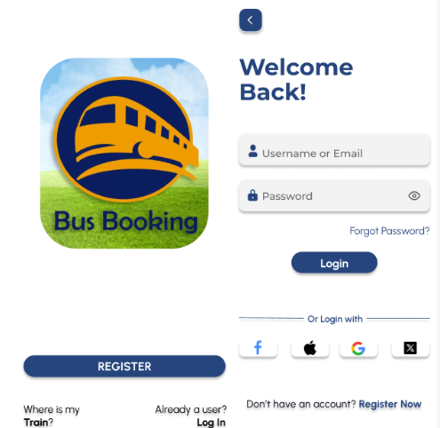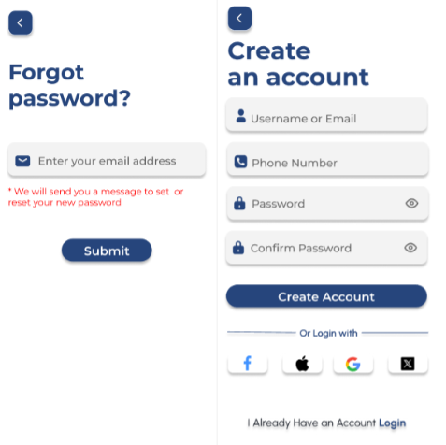
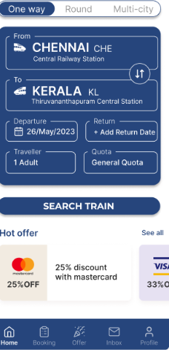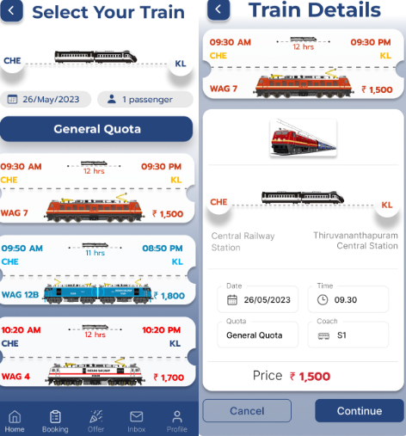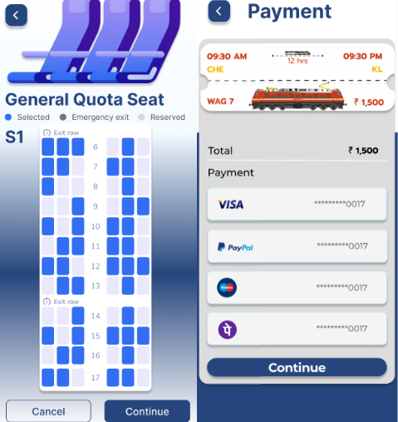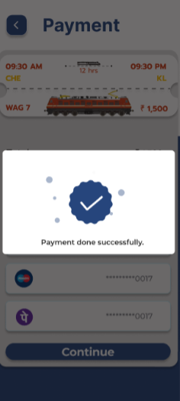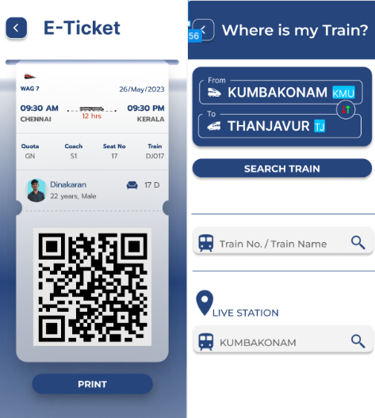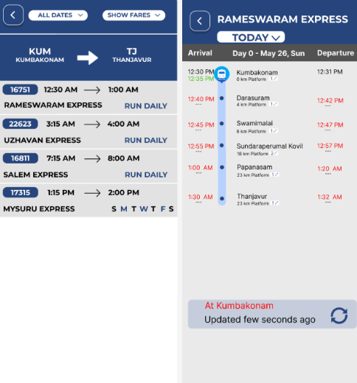

Prototype:
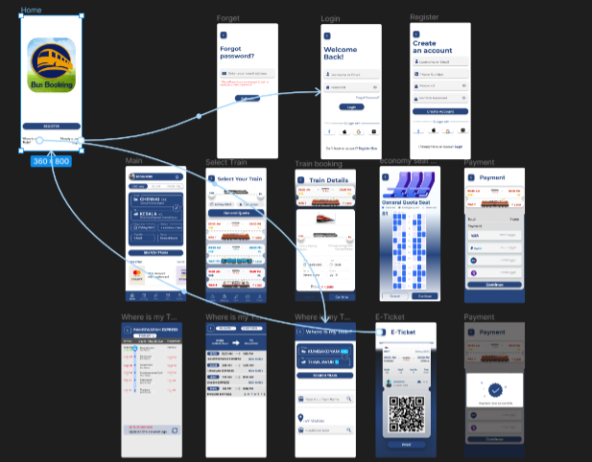
Result: -
A user interface prototype for a mobile station using Figma, considering connectivity and
convenience using Figma is created and executed successful

